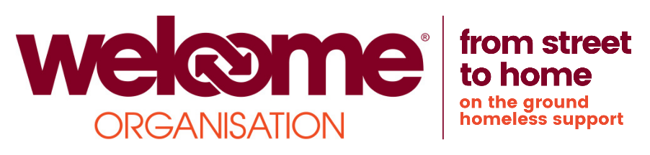

Full time – Caseworker (up until 12 January 2023 with possibility of extension depending on funding)

Job Description
This is an exciting opportunity to be part of a team of caseworkers meeting the needs of homeless and vulnerably housed clients. As a caseworker you will provide holistic support to a caseload of clients, as well as providing a daily support clinic in the Drop In.
Some clients will be new to homelessness but many will have complex and multiple needs including; repeat homelessness, significant histories of trauma, mental health, addiction and family breakdown and some will also have struggled to engage with other support services which exacerbates and prolongs their homelessness experience and results in them ‘revolving’ around the system.
If you are motivated, resourceful and passionate about empowering and supporting homeless people then join our team. You must be able to provide holistic support, be aware of the benefits of trauma-informed and strength-based environments and work to the Welcome ethos of low threshold and high tolerance services. In return, we will provide the opportunity to develop your skills, professional supervision and support, along with being part of a team where your views count and where you can make a lasting difference to the lives of homeless women.
Job Title | Case Worker
Responsible to | Assistant Manager Case Management Team
Rate | £19,032.00 per annum (pro rata)
Days of Work | 37.5 hours - This comprises of a 40 hour week with a daily 30 minute unpaid lunch break. This is a new role that requires a degree of flexibility. We envisage that most hours will typically be between 8am and 6pm Monday to Friday but you will be expected to work evenings/weekends depending on client need.
Holidays | 20 days per annum plus Public/Bank Holidays (or pro rota)
Closing Date | Monday 29 November 2021, 9am

Main Duties and Tasks

As part of a team of Caseworkers you will have particular responsibility for meeting the immediate and ongoing general and emotional support needs of homeless people who present to the Drop In and those in Temporary Accommdation (during Covid-19). The support will be holistic and person centred and aimed at clients successfully transistioning out of homelessness.

Identifying clients
- Working in conjunction with the Northern Ireland Housing Executive, Welcome staff and other agencies promote the service and identify clients who fit the support criteria.

Providing support
- Build trusting and meaningful relationships with clients whilst keeping within professional boundaries and our ethos of low threshold and high tolerance.
- Key-work a caseload, design and implement person-centred and holistic needs/risk assessments and support plans, ensure regular 1 to 1 meetings to review progress towards goals.
- Provide a Drop In clinic to meet the needs of those presenting with issues that need immediate support.
- Provide varied support to reflect the needs of clients at the stage of homelessness they are in i.e. rough sleeping, temporary accommodation and ‘sofa surfing’.
- Provide trauma informed and strength-based support, which enables clients to address underlying psychological and emotional issues and helps them to develop resilience and other ‘tools’ needed to successfully maintain independent living.
- Support clients to access programmes and workshops which improve their awareness of healthier choices around risky activities, confidence building, self- esteem and personal development.
- Support clients to refer, access and sustain engagement with other services in order to address their needs such as benefits, housing, health, criminal justice, social care etc.
- Work with other agencies to provide ‘wraparound’ support including initiating and leading multi-agency case conferences and ensuring support is considered and consistent in a way that works for the clients.
- Identify barriers preventing clients from accessing support services and advocate on their behalf while raising awareness of their rights.

Monitoring the service

- Maintain accurate records including, handovers, contact notes, case files and databases etc.
- Co-operate with the monitoring framework in order to enable external evaluation of the service.
- Set up, collate, evaluate and report for both qualitive and quantitive data as required by funders and management.

General

- Promote a climate of understanding of the causes and consequences of homelessness.
- Keep abreast of relevant developments in the sector including training and other opportunities specific to the role.
- Effectively manage time and meet deadlines while having the flexibility to meet the demands of the service and its’ users.
- Ensure all vulnerable adults and children at risk are safeguarded appropriately.
- Actively participate in training, supervision, apprasials and team meetings.
- Attend meetings as required.
- Support and promote Service User Involvement, and Diversity and Equality of Opportunity within the workplace.
- Maintain safe systems of work and a safe environment.
- Adhere to all The Welcome’s policies and procedures.
- Undertake any other duties relevant to the post or business needs.
Person Specification
Criteria | Essential | Desirable
Previous experience | - 1 year experience supporting clients with complex and multiple needs
Skills/Ability | - Ability to develop person-centered needs/risk assessments and support plans and manage a key worker case load  - Ability to take the lead and work in partnership with other agencies  - Ability to access local/community based programmes  - Ability to self-manage, work in a team and have excellent organisational skills.  - Ability to manage people with challenging behaviour and poor levels of engagement  - Excellent written/verbal communication, numerical and interpersonal skills  - Ability to adhere to Diversity and Equal Opportunities, Health & Safety, Protection of Vulnerable Adults, Confidentiality and other policies/procedures  - Be competent in the use of IT applications  - Ability to work in a busy environment, be solution and target focused, show good time management skills and make decisions under pressure
Education / knowledge | - Thorough understanding of the causes and consequences of homelessness  - Understanding of the impact of trauma and how to work in a trauma informed and strength-based way.  - Working knowledge of alcohol/substance misuse/mental health issues and harm reduction principles  - Thorough understanding of the wider needs and support services relevant to homeless people  - Knowledge of monitoring and evaluation systems and the ability to keep files and accurate notes  - Understanding and commitment to working within our ethos of High Tolerance, Low Threshold services | - Mental Health level 3 (or above) qualification
Personal Attributes | - Highly motivated, resourceful and passionate about reducing the numbers of people experiencing homelessness  - Committed to advocating and raising awareness of homeless peoples’ rights  - Highly effective and committed to personal and professional development  - Friendly and approachable  - Non-judgemental with the ability to empathise  - Resilient and self-caring
Other | - Able to work flexible hours as required including some weekend and evenings  - A satisfactory Enhanced Access NI check  - The post holder will be required to wear identifiable clothing (uniform) whilst working  - Car driver with access to a car insured for business purposes (or transport that allows the candidate to fulfil the duties of the post)

